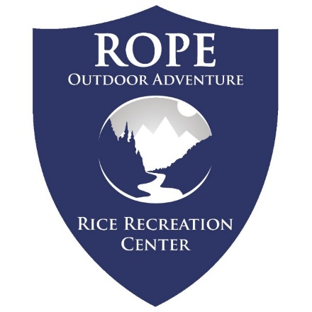
Mountain Backpacking

Registration Closes April 25th at 12pm.

Prior backpacking experience is required to participate in this expedition. Prior ROPE trip participation preferred.

This trip has lots of information. Participants must thoroughly review trip timeline, plans, and gear. Area conditions may change trip timeline up to 2 days – ROPE will provide updates

Informational Meeting:
Sunday April 19
7:00 PM in Rec Classroom 160A

Mandatory Pre-Trip Meeting
Tuesday May 5
12:00-3:00PM at Rec Center Classroom 160A
Bring all of your personal gear and trip clothes. Failure to have required personal gear will result in forfeit of trip registration.
We’ll discuss final trip logistics and check personal readiness.
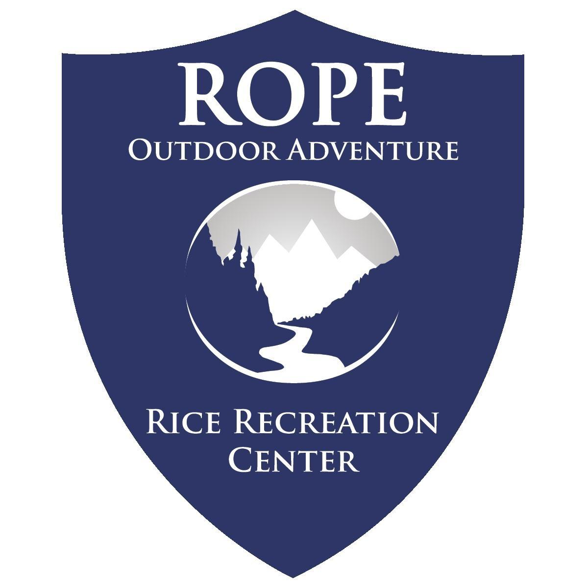
Mountain Backpacking
Gila Wilderness, New Mexico
May 7 - 16
Trip Leaders: Kris

Early registration discount ends March 24.
Registration closes April 25 at 12pm or
when capacity is reached.

Informational Meeting about Trip:
Friday April 19 – 5PM
Mandatory Trip Meeting:
Tuesday May 5 - 12PM

Tuesday May 5
12-3pm Pre Trip Meeting
Gear Issue, Food Packing, & Trip Review
Wednesday May 6
6:00AM – Meet at Outdoor Adventure Center
6:15 AM – Depart Rice
*Breakfast & Lunch on the road
Estimated 13 hours of travel. Camp en route ex. Franklin Mtn. State Park
4:30PM – ETA Camp. Gear orientation and dinner.
Thursday May 7
7:00 AM – Breakfast
8:00 AM – Depart for Trailhead
*Lunch on the road
Estimated 4 hours of travel. Camp near Trailhead.
4:00 PM – ETA Camp. LNT orientation, gear organization, & dinner.
Friday May 8 – Tuesday May 14
On the trail in the mountains & rivers, having a blast!
Wednesday May 15
6:30 AM – Breakfast
9:00 AM – Exit Trailhead
*Lunch on the Road
3:00PM – Camp en route to Campus ex. Las Cruces
Shower and *Victory Meal in Town.
Thursday May 16
6:30 AM – Light Continental Breakfast
7:30 AM – Depart for Rice
*Lunch, & Dinner on the Road
7:00 PM – ETA at Rice
Gear Cleaning and Check-In. Estimated 90 minutes.
8:30 PM – ETA Trip Complete
*Participants cover meals while driving to locations.
ROPE is always excited to return to the mountains of New Mexico! This region holds special meaning to our director for its stunning views and fabulous weather. The mountains offer a cool escape from the growing spring heat alongside rewarding challenges and picturesque vistas. This trip is primarily a training trip for new ROPE leaders. Registration fees are reduced for participants as they join new leaders learning to lead under the guidance of the program director.
Final trail itineraries will not be available until late April as the program follows weather and snow reports. With many of the trail options above 7,000 feet and peak destinations at 10,000 feet, high elevation, river crossings, and snow features that the trip and participants should prepare for. Mountain backpacking requires good fitness alongside strong mental fortitude to work through the physical and environmental challenges.

This trip is reserved for student participants. Prior backpacking experience is required, and participants will be screened prior to registration.
Registration covers transportation, meals on trail, equipment, and associated recreation fees. Participants are responsible for meals while traveling to location. Participants assist with gear clean-up to encourage gear care and reduce trip costs. Registration includes a $200 deposit.

Mountain weather can change unpredictably, but in general we can expect days in the mid 60’s and nights in the mid 30’s. Packing for cold weather will increase participant comfort and enjoyment out on trail even if temperatures are above average. Participants should expect wet conditions in all areas from stream crossings, river walking, or snow melt.
Participants are expected to:
- Be in good physical and mental health and possess the physical strength to manage challenges including: carry a 45-55 pound backpack, hike for 6-10 miles over rugged terrain, maintain composure during challenges.
- This trip will frequently be traveling above 6,000 feet in elevation which can be challenging for even athletic individuals.
- Learn and practice exemplary Leave No Trace philosophy and methods.
- Follow directions where the group takes precautionary action to minimize risk.
- Provide essential footwear and clothing that meets the demands of this trip.
Hiking boots/shoes are required. Sneakers and running shoes will not be permitted as hiking footwear. Waterproof boots are not recommended for the Gila Wilderness.
Uphold technology hiatus. Cell phone use will be restricted to photography only

Gear Guide for Cold Weather Extended Backpacking Trips
Please dress & pack appropriately for this trip. Review the guide below to support a comfortable and successful backpacking trip!

All the gear listed as provided is included in your trip registration. Rental agreements and gear issue will take place during your pre-trip meeting.

Necessary Personal Items:
- 1 Pair of Hiking Boots or Hiking Shoes
- 3-4 of hiking socks (synthetic or wool)
- 1 Hooded Rain Jacket (No Ponchos)
- 1 heavy fleece or down jacket
- 1-2 Long sleeve synthetic shirts (NO Cotton)
- 1-2 synthetic T-shirts (NO Cotton)
- 3-4 underwear
- 1-2 synthetic pants (NO Cotton)
- 0-1 pair of synthetic shorts
- 1 insulating long-sleeve shirt
- 1 insulating legs layer
- 1 warm hat
- Warm gloves
- Personal toiletries (Toothbrush, etc.)
- 2 Bottles for water (storage for 2 liters/64 oz)
- Small and lightweight face towel (4x4in)
- Medications (for allergies, etc.)
You must inform us if you take any medications.
- Money for meals on the road (if applicable)
- Passport & Travel Visas (Intl. Students)

Equipment ROPE provides:
- Backpack w/ rain cover
- Sleeping Bag
- Sleeping Pad
- Bowl & Personal Utensils
- Headlamp
- Whistle
- Tents
- Cooking Equipment
- Trail Meals

Optional yet recommended
- Sunglasses (strongly recommended)
- Camera (H2O protection encouraged)
- Campshoes (lightweight; e.g. sandals)
- 1 pair of waterproof pants
- Sun hat
- Bandana(s)
- Journal & Pen
- Cards/Game
- Water reservoir (Camelbak)
  - One-liter back-up bottle required.

Small Bag for Travel
- 1 pair pants/shorts
- 2 shirts
- 2 underwear
- 1-2 socks
- Clean footwear
- Toiletries & Towel for shower
- Small bag (backpack or smaller)

For extended trips plan your clothing around 2 sets of clothes: 1 set for being active that will likely get wet from weather or exertion, and 1 set for camp which always remains packed and dry. A set of clothes per day is unrealistic and unmanageable, but an extra t-shirt and/or pair of socks are small and meaningful additions for many participants.

*Footwear Guidance: Appropriate footwear for backpacking is a sliding scale largely based around prior experience and terrain. The more challenging and rocky a trail is, the greater requirement for hiking shoes or boots. An established trail through the forest offers more flexibility for trail shoes. Participants with weeks of trail experience may consult with trip leaders on preferred footwear. Some restrictions may still apply including prohibitions on sandals.

It is not necessary for you to purchase a set of new expensive equipment; many items listed above you may already own as athletic or day-to-day apparel. Check with your friends for options to borrow or rent items too. Items that you choose to purchase may be available at low cost from online suppliers or local thrift store. Our primary concern is that all participants have appropriate equipment for a safe and comfortable experience.

If you are unsure whether an item or clothing you own is appropriate for this trip, please contact us prior to the trip or bring the item/clothing to the pre-trip meeting.

Please leave jewelry and other non-essentials at home.

Alcohol, tobacco, and recreational drugs will not be tolerated on any trips led by ROPE. If you have such items, do not bring them!

These requirements are for the safety and comfort of participants. ROPE reserves the right to refuse involvement in the program to anyone not properly equipped.

Gear List According to Use
It may be helpful to consider the packing list from this perspective as well. Participants will have a set of clothes to actively move and travel in, and then a second set of clothes for camp that will remain clean and dry to help them remain comfortable as the weather cools. Few if any spare clothes should be brought as your pack weight increases and pack space decreases with each additional item.

Essential items ROPE provides:

- Backpack
- Sleeping Bag & Liner
- Sleeping Pad
- Bowl & Personal Utensils
- Headlamp
- Tents
- Cooking Equipment
- Trail Meals

Required Small Bag for road travel:
- Small Duffle/Backpack (<30Liters)
- 1 pair pants/shorts
- 2 shirts
- 2 underwear
- 1-2 socks
- Toiletries & towel for shower
- 1 pair of clean footwear (can be camp shoes)

Required “Wet” Backpacking Clothes
No Cotton Clothing.

- 1 Pair of Hiking Boots or Hiking Shoes
- 1-2 synthetic shirt (long or short sleeve)
- 1 Long sleeve synthetic shirt
- 0-1 pair of synthetic shorts
- 1 pair of synthetic pants
- 1-2 pair of hiking socks (synthetic or wool)
- 1-2 of underwear

Required “Dry” Camp Clothes & Items

- Medications - You must inform us if you take any medications.
- 1 Hooded Rain Jacket (No Ponchos)
- 1 insulating jacket (down or synthetic)
- 1 layering top (fleece or midweight)
- 1 warm hat
- 1 pair of hiking socks (synthetic or wool)
- 1-2 of underwear
- 0-1 synthetic shirt (long or short sleeve)
- 0-1 pair of synthetic shorts
- 1 pair of synthetic pants or rain pants
- Camp shoes (lightweight; e.g. sandals/crocs)
- Bandana, Buff, or similar cloth
- Personal Toiletries (Toothbrush, Toothpaste, small soap)
- Small and lightweight face towel (4x4in)
- Sunglasses – Polarized is recommended
- Small sunscreen
- 2 Bottles for water (storage for 2 liters)

Optional/Recommended:
- Camera (H2O protection encouraged)
- Sun hat
- Camelback water bladder
- Personal Water Filter
- Favorite Snack Foods (small amount)
- Book/Games/Journal
- 1 insulating bottom (base or midweight)
- 1 pair of gloves

You made it!

Complete interest submission first.

Register for the Trip!

