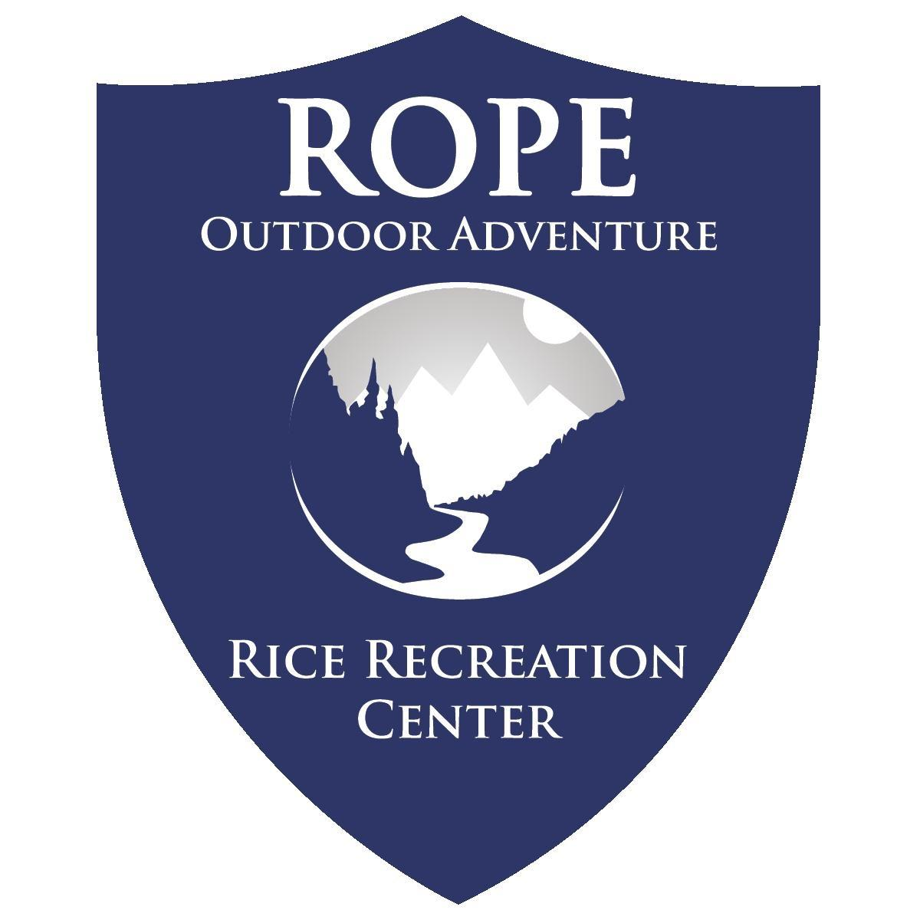
Day Kayaking
Brazoria NWR, TX – Drum Bay
April 5
Trip Leaders:

Registration closes March 25 at 12pm or
when capacity is reached.

Sunday April 5
8:00AM Depart from Rice
10:00-10:45 Stage
11:00 Paddle
Lunch on River
3-4:00PM ETA Exit River
4:00-4:30PM Load Trailer/Pack Up
ETA 6:00PM Return to Rice and clean-up

All kayaking trips require completing a pool session with trip leaders to demonstrate ability to exit kayaks confidently. The ability to swim independently is required to join this trip.

Home to more than 100,000 migrating birds, Brazoria National Wildlife Refuge is a coastal wetland at the edge of the gulf coast featuring a fresh water slough that winds through salt marshes. Our 7-9 mile paddle will take through lagoons and marshland out onto the coastal Drum Bay. If conditions and energy are good we will cross to the barrier island of Follet’s Island before returning to our put-in.

This trip is open to participants of all experience levels but the ability to swim is required.
Registration covers transportation, meals on trail, equipment, and associated recreation fees. Participants are responsible for meals while traveling to location. Participants assist with gear clean-up to encourage gear care and reduce trip costs.

According to weather and water conditions this trip may shift to an alternative paddling location.

Gear Guide for Warm Weather

Day Paddle Trips
Please dress & pack appropriately for this trip. Review the guide below to support a comfortable and successful backpacking trip!

All the gear listed as provided is included in your trip registration. Rental agreements and gear issue will take place during your pre-trip meeting or the day of trip.

Equipment ROPE provides:
- Watercraft
- Life Jacket
- Meals on Trail
- Water Reservoirs
- Bowl & Utensils (as needed)
- Headlamp (as needed)
- Dry Bags (as needed)

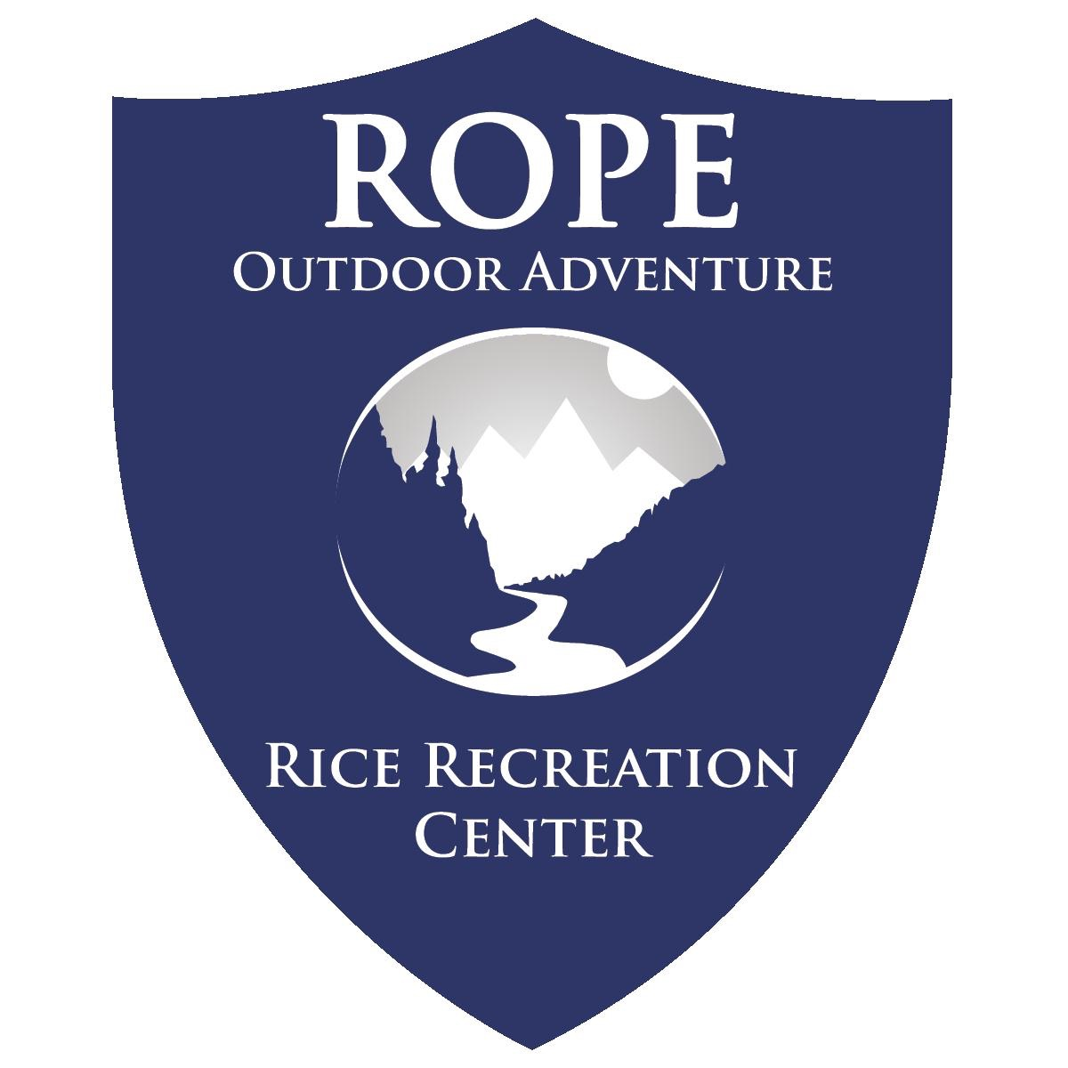

Necessary Personal Items:
- Two 1-liter water bottles (ex. Nalgene)
- 1 Pair Shoes/Sandals for the water
Footwear will be wet and must have a heel strap and be appropriate for stepping in rocky water.
- Rain jacket
- Long sleeve shirt – Sun Shirt
- Swimwear or synthetic clothing
- Sunglasses (polarized recommended)
- Preferred Sunscreen
- Hat
- Towel
- Spare set of Dry Clothes & Footwear
- Clean shoes for the van

Optional yet recommended
- Backpack/day pack
- Camera
- Medications, if any taken
- Additional snacks
- Insect Repellent (DEET free)

It is not necessary for you to purchase a set of new expensive equipment; many items listed above you may already own as athletic or day-to-day apparel. Check with your friends for options to borrow or rent items too. Items that you choose to purchase may be available at low cost from online suppliers or local thrift store. Our primary concern is that all participants have appropriate equipment for a safe and comfortable experience.

If you are unsure whether an item or clothing you own is appropriate for this trip, please contact us prior to the trip or bring the item/clothing to the pre-trip meeting.

Please leave jewelry and other non-essentials at home.

Alcohol, tobacco, and recreational drugs will not be tolerated on any trips led by ROPE. If you have such items, do not bring them!

These requirements are for the safety and comfort of participants. ROPE reserves the right to refuse involvement in the program to anyone not properly equipped.

Register for the Trip!

