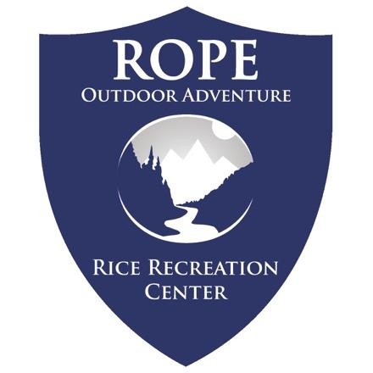
Intro Backpacking
Little Lake Creek Wilderness, TX
January 24-25
Trip Leaders:

Registration closes January 21 at 12pm or when capacity is reached.

January
Mandatory Pre-Trip Meeting TBA

Saturday January 24
7:30AM Meet at ROPE
8:00AM Depart from Rice
10:30AM Arrive at Trailhead and Begin Hiking
Evening in the Backcountry

Sunday January 28
8:00AM Breakdown Campsite
Hike back to the trailhead
2:00PM Depart for Rec Center
3:30PM ETA at Rice
5:00PM ETA Finish Trip Check-in and Gear Clean-up

Sam Houston National Forest is a beautiful forested wilderness area just out of Houston, including foothill mixed hardwoods and cypress bayous. In this area, the forest has been allowed to return to a more natural state free of human activity, giving us a taste of an undisturbed forest. We will hike a loop through the forest including sections of the Little Lake Creek and Lonestar Trails. Each day will be less than 6 miles with little elevation change. Join us for an introduction to backpacking and camping basics, a great hike, and an escape from the hustle and bustle of life in Houston.
Registration covers transportation, meals on trail, equipment, and associated recreation fees. Participants are responsible for meals while traveling to location. Participants assist with gear clean-up to encourage gear care and reduce trip costs.
All ROPE trips feature “disconnect to reconnect” agreement- Phones will be permitted for photos but all other services will be turned off.

Gear Guide for Cold Weather

Backpacking Trips
Please dress & pack appropriately for this trip. Review the guide below to support a comfortable and successful backpacking trip!

All the gear listed as provided is included in your trip registration. Rental agreements and gear issue will take place during your pre-trip meeting.

Equipment ROPE provides:
- Backpack w/ rain cover
- Sleeping Bag
- Sleeping Pad
- Bowl & Personal Utensils
- Headlamp
- Whistle
- Tents
- Cooking Equipment
- Meals on Trail

Necessary Personal Items:
- 1 Pair of Hiking Boots or Hiking Shoes*
- 1-2 of hiking socks (synthetic or wool)
- 1 Hooded Rain Jacket (No Ponchos)
- 1 heavy fleece or down jacket
- 1-2 Long sleeve synthetic shirts
- 1-2 synthetic T-shirts (NO cotton)
- 1-2 of underwear
- 0-1 synthetic shorts
- 1-2 synthetic pants (NO cotton)
- 1 insulating long-sleeve shirt
- 1 insulating legs layer
- 1 warm hat
- Warm gloves
- Personal toiletries (Toothbrush, etc.)
- 2 Bottles for water (storage for 2 liters/64 oz)
- Small and lightweight face towel (4x4in)
- Medications (for allergies, etc.)
You must inform us if you take any medications.
- Money for meals on the road (if applicable)
- Clean shoes for travel
- Passport & Travel Visas (Intl. Students)

Optional yet recommended
- Sunglasses (strongly recommended)
- Camera (H2O protection encouraged)
- Campshoes (lightweight; e.g. sandals)
- 1 pair of waterproof pants
- Sun hat
- Bandana(s)
- Journal & Pen
- Cards/Game
- Water reservoir (Camelbak)
  - One-liter back-up bottle required.

*Footwear Guidance: Appropriate footwear for backpacking is a sliding scale largely based around prior experience and terrain. The more challenging and rocky a trail is, the greater requirement for hiking shoes or boots. An established trail through the forest offers more flexibility for trail shoes. Participants with weeks of trail experience may consult with trip leaders on preferred footwear. Some restrictions may still apply including prohibitions on sandals.

It is not necessary for you to purchase a set of new expensive equipment; many items listed above you may already own as athletic or day-to-day apparel. Check with your friends for options to borrow or rent items too. Items that you choose to purchase may be available at low cost from online suppliers or local thrift store. Our primary concern is that all participants have appropriate equipment for a safe and comfortable experience.

If you are unsure whether an item or clothing you own is appropriate for this trip, please contact us prior to the trip or bring the item/clothing to the pre-trip meeting.

Please leave jewelry and other non-essentials at home.

Alcohol, tobacco, and recreational drugs will not be tolerated on any trips led by ROPE. If you have such items, do not bring them!

These requirements are for the safety and comfort of participants. ROPE reserves the right to refuse involvement in the program to anyone not properly equipped.

Register for the Trip!

